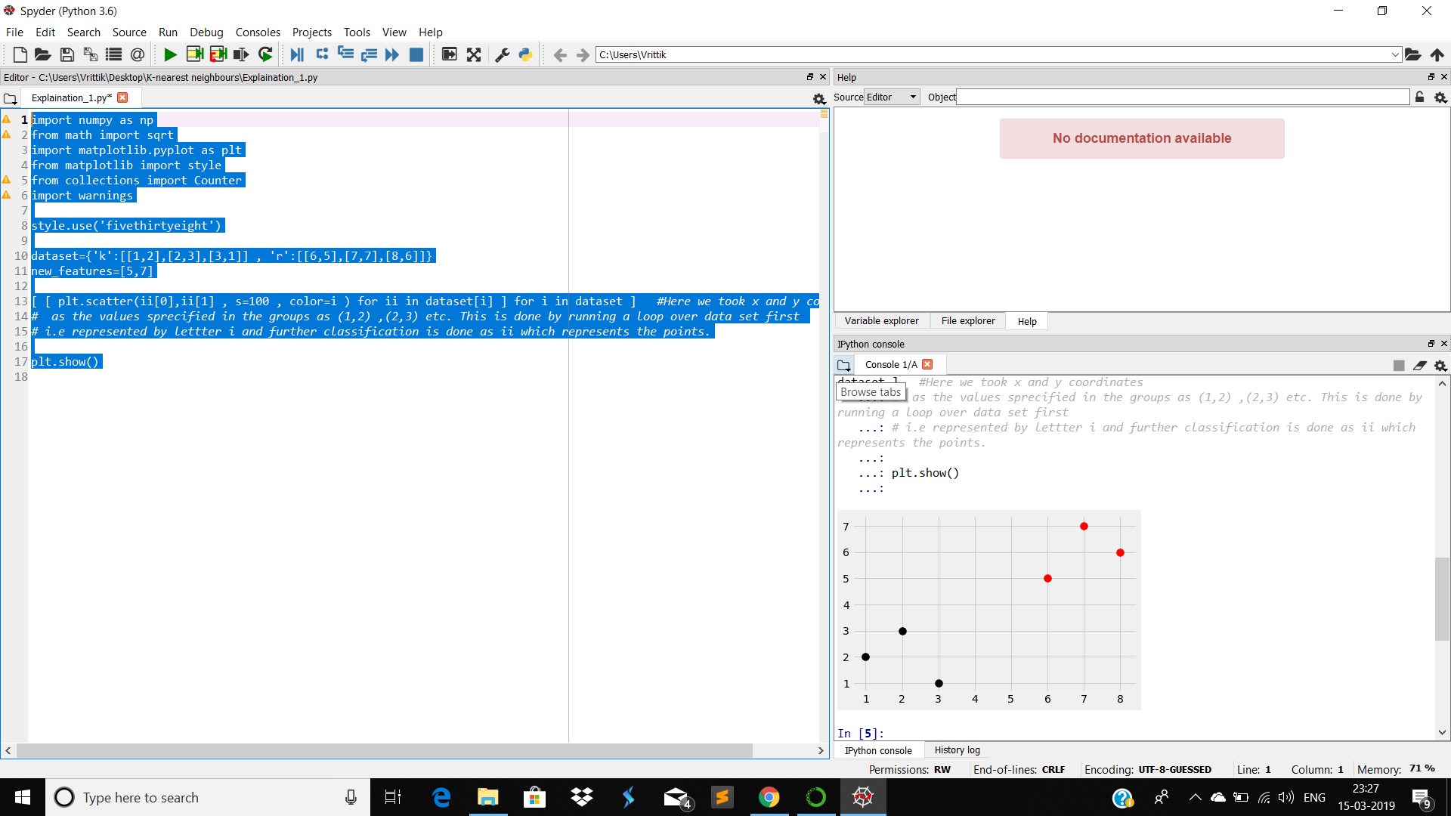

Figure -1 : It denotes the groups

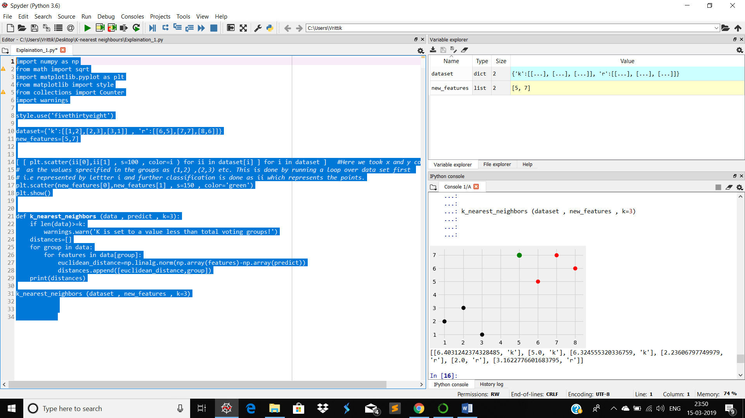

**FIGURE -2** : THIS REPRESENTS THE DISTANCE BETWEEN GREEN POINT AND ALL OTHERS. ALSO THE CATEGORY IS SHOWN.

Category 1: ‘**K**’

Category 2: ‘**r**’

Green point: Point to be classified as Red or Black (Point needed to be set to a fixed group (black,red)) .

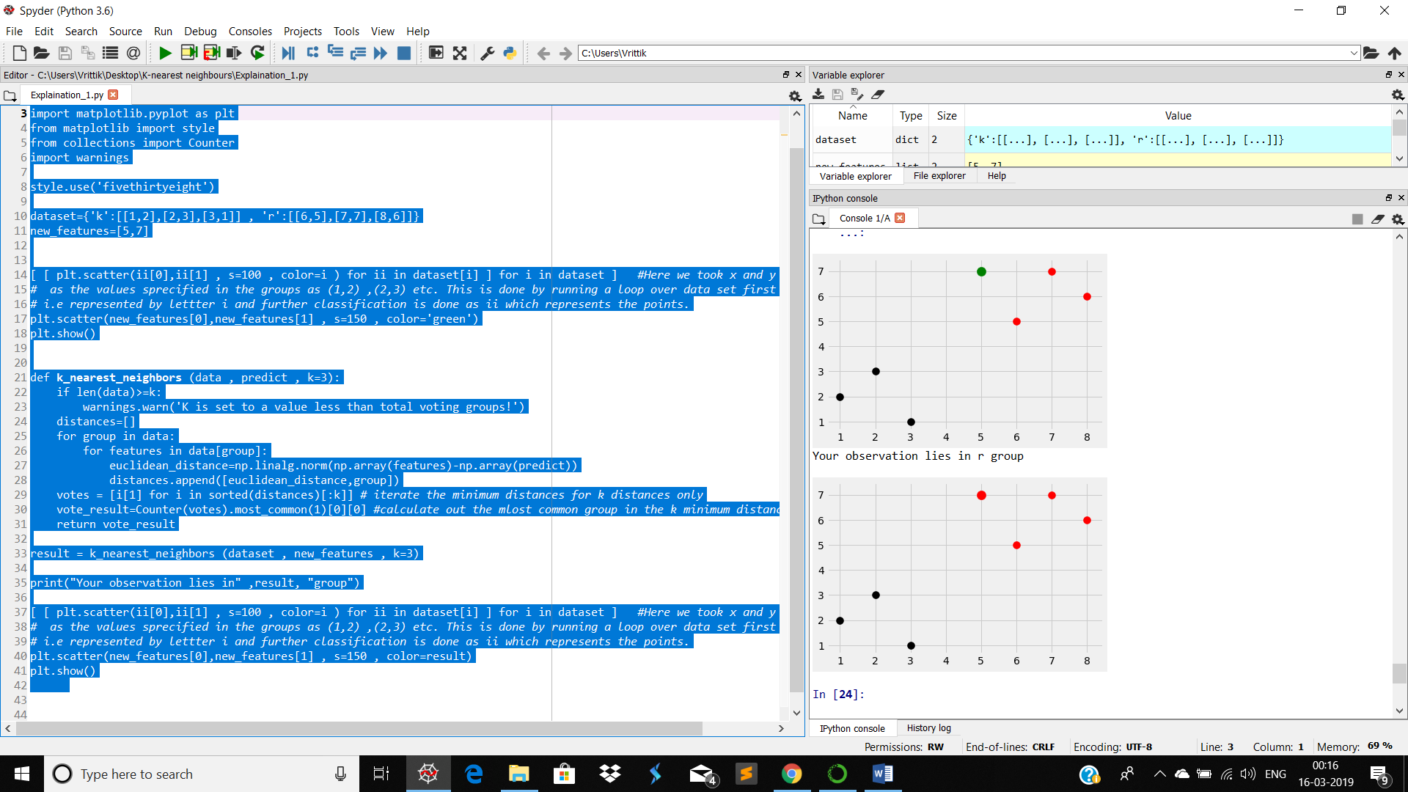

Figure -3: The prediction value is detected and color of the desired point is replaced with the color of the group in which it lies.

`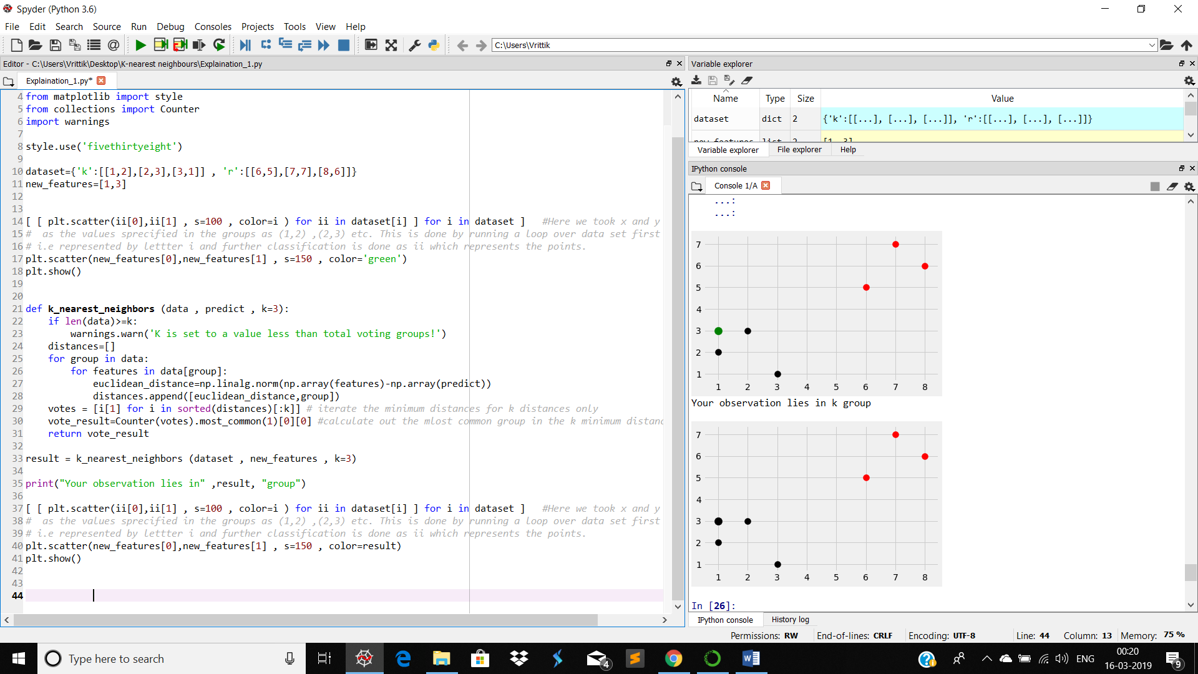

Figure-4: New point close to the black group

# Attribute Domain

-- -----------------------------------------

1. Sample code number id number

2. Clump Thickness 1 - 10

3. Uniformity of Cell Size 1 - 10

4. Uniformity of Cell Shape 1 - 10

5. Marginal Adhesion 1 - 10

6. Single Epithelial Cell Size 1 - 10

7. Bare Nuclei 1 - 10

8. Bland Chromatin 1 - 10

9. Normal Nucleoli 1 - 10

10. Mitoses 1 - 10

11. Class: (2 for benign, 4 for malignant)

# data set column specification/